Civil war in Somalia

UNSC Resolution: | 746
Date of adoption: | 17-Mar-1992
Operative paragraph: | 2
Demand number: | 746,0211

Sarah-Myriam Martin-Brûlé

Wording of demand
- honour their commitment under the cease-fire agreements signed at Mogadishu on 3 March 1992

List of addressees of the demand
- Government of Somalia, United Somali Congress Faction

Short-term compliance

Description of the addressee(s)’ conduct

“The Security Council Friday night authorized a small new peacekeeping operation in the northeast African nation of Somalia, voting to send 50 military observers to monitor a fragile six-week truce between warring factions fighting for control of the gutted capital, Mogadishu.”

Paul Lewis. 1992. “Reined In by U.S., U.N. Limits Mission to Somalia. New York Times, Sunday, April 26, 1992

http://www.nytimes.com/1992/04/26/world/reined-in-by-us-un-limits-mission-to-somalia.html

“Ian MacLeod, the United Nations spokesman in Mogadishu, said in a telephone interview that the officers "were cordially received and wished well in their work." The remaining observers are to arrive by July 13.
Mr. Ali Mahdi and his rival, Gen. Mohammed Farrah Aidid, chairman of the United Somali Congress, agreed to the United Nations-sponsored cease-fire on March 3 after a five-month battle for control of the city.
Mr. MacLeod said that the cease-fire "has basically held," but that sporadic gunfire is continuing.

“U.N. Truce Observers Reach Somali Capital”, New York Times, Monday July 6 1992.
http://www.nytimes.com/1992/07/06/world/un-truce-observers-reach-somali-capital.html

“A fragile cease-fire is barely holding and poor security has virtually halted relief efforts in this nation, where an estimated 200 people die of starvation each day.”
“U.N. Meets With Rival Factions in Somalia”, New York Times, Friday, August 7, 1992
http://www.nytimes.com/1992/08/07/world/un-meets-with-rival-factions-in-somalia.html

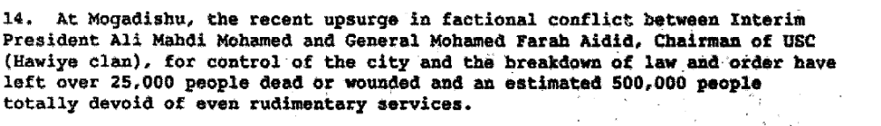

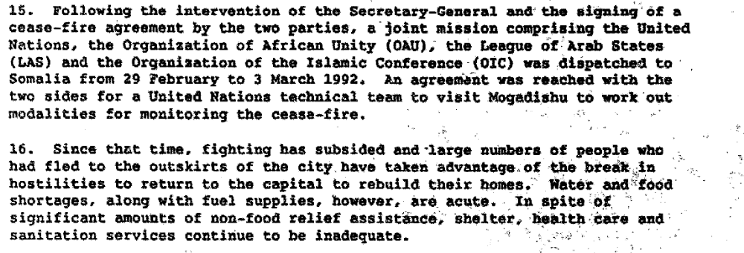

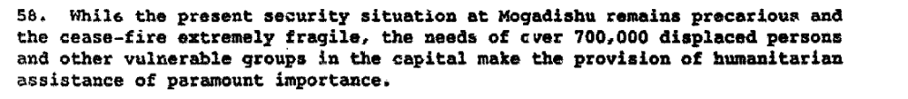

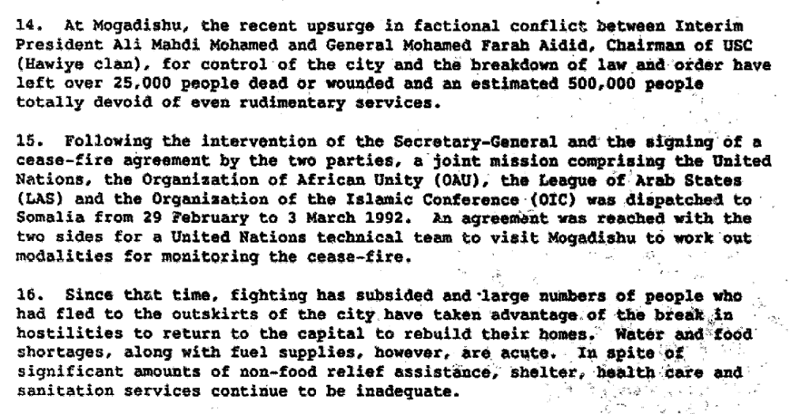

Report of the Secretary General on the Situation in Somalia, 21 April 1992 S/23829/Add.1.

Assessment

Short-term compliance
No or marginal compliance (1) | Medium low compliance (2) | X Medium high compliance (3) | Full or almost full compliance (4)

Considerations underlying the assessment

Albeit the break-out of some hostilities between the demand addressees, the cease-fire agreement signed at Mogadishu on 3 March 1992 generally did uphold within the six months following the adoption of the resolution.

Medium-term compliance

Description of the addressee(s)’ conduct

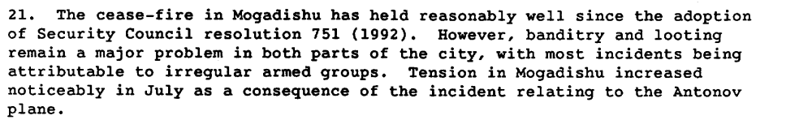

Report of the Secretary General on the Situation in Somalia, 22 July 1992 S/24343

“unprovoked armed attacks against the personnel of UNOSOM II on 5 June 1993, which appear to have been part of a calculated and premeditated series of cease-fire violations to prevent by intimidation UNOSOM II from carrying out its mandate as provided for in resolution 814 (1993);”

UN Security Council Resolution 837 on Somalia - United Nations Security Council

Assessment

Medium-term compliance
X No or marginal compliance (1) | Medium low compliance (2) | Medium high compliance (3) | Full or almost full compliance (4)

Considerations underlying the assessment
The cease-fire was broken within the two years following the adoption of the resolution.

Depth of demand

Assessment

Level of depth of demand
Low depth of demand (1) | X Medium depth of demand (2) | High depth of demand (3)

Considerations underlying the assessment

“Aideed was opposed to any deployment of UN personnel and to a cease-fire. He perceived thse as means of freezing the status quo and preventing him from defeating Mahdi, which he considered he was in a position to do in a relatively short time. “
Ray Murphy.2007 UN Peacekeeping in Lebanon, Somalia and Kosovo. Cambridge University Press. p. 50 .

Level of confidence about coding decisions

Level of confidence about coding decision
Extremely high | X High | Moderate

Comments to IPI (if any)

